Link

Objective

Vrinda store wants to create an annual sales report for 2022. So that, Vrinda can understand their customers and grow more sales in 2023.

Sample Questions

* Compare the sales and orders using the single chart
* Which month got the highest sales and orders?
* Who purchased more-men or women in 2022?
* What are different order status in 2022?
* List top 10 states contributing to the sales?
* Relation between age and gender based on number of orders.
* Which channel is contributing to maximum sales?
* Highest selling category? Etc.

1. IS this data is sufficient to solve my problem or not?
2. Data cleaning
3. Data processing
4. Data Analysis

**Sample Insights**

* Women are more likely to buy compared to men(~65%)
* Maharashtra, Karnataka and Uttar Pradesh are the top 3 states (~35%)
* Adult age group (30-49 yrs) is max contributing (~50%)
* Amazon, Flipkart and Myntra channels are max contributing

Final Conclusion to improve Vrinda store sales:

Target Women customers of age group (30-49 yrs) living in Maharasthtra, Karnataka and Uttar Pradesh by showing ads/coupons/ offers available on Amazon, Flipkart and Myntra.

* Compare the sales and orders using the single chart

The sales and orders using the single chart has been described below figure

To do this we follow the following steps in excels:

Step 1: data clean

Step 2: data preprocessing

Step 3: Create a pivot table

Step 4: filter pivot table using Month name and total amount sales and order

Step 5: based on suitable data output we provide suitable charts like bar chart, pie chart, scatter chart etc.

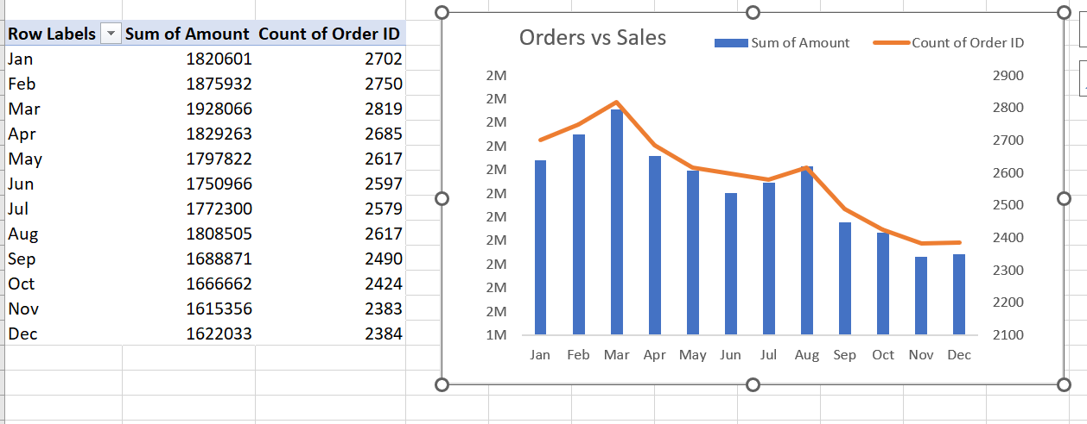

Finally we make Annual report for Vrindha store

Step 1: Based on question, we copy the chart from the different sheets of the excel and paste it into the in a single sheet

Step 2: Design the template to look attractive

Step 3: Insert the slicer to filter data based on different parameters like (month, gender, state, status, channels etc)

The final report of the Vrinda store is given below

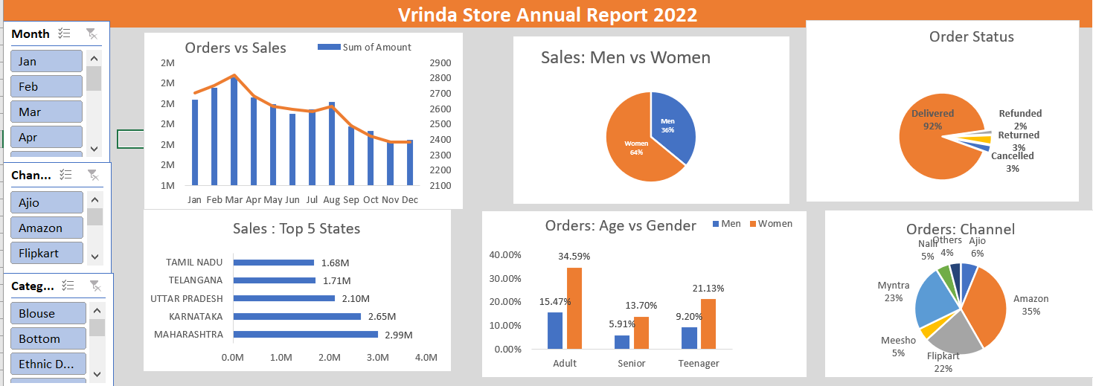

Some examples

Let’s do the filter like Month: January, Channel:Flipkart, Category: Saree

The output is as follows

